

ENDURO_RR_430_4T_RACING_MY22
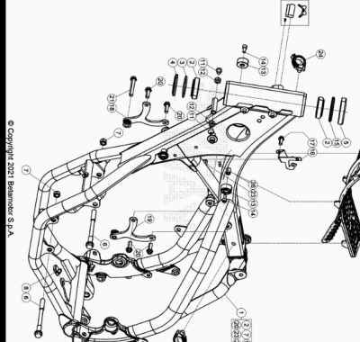

ENDURO_RR_430_4T_RACING_MY22
Ref. | Part Number | Description | Part
1 | 037.31.058.80.50 | CHASIS RR 4T MY 20 | 1
2 | 12.99510.000 | COJINETE CÓNICO 29X50X15 RR-4T | 2
3 | 10.66935.000 | JUNTA TÓRICA RR-4T | 1
4 | 020.31.039.00.00 | GUARDAPOLVO DIRECCION | 1
5 | 031.31.016.22.00 | PROTECCION COJINETE | 1
6 | 11.64607.000 | TORNILLO ESPECIAL RR-4T | 2
7 | 13.21060.000 | TUERCA AMBRIDADA M10 X 1,25 | 2
8 | 25.60311.000 | GRAPA TORNILLO M6 ALP 4.0 2008 | 1
9 | 037.31.024.00.00 | CERRADURA BLOCAJE | 1
10 | 037.31.071.00.59 | GOMA PROTECTOR DEPOSITO | 1
11 | 31.64060.000 | TORNILLO TBIB 8.16 | 2
12 | 13.16000.000 | TUERCA 8.6 CH13 | 2
13 | 29.10310.000 | TOPE GOMA DEPOSITO TR-34/RR-4T | 2
14 | 31.31050.000 | TORNILLO ALLEN TCCE 6.15 | 2
15 | 031.32.007.00.00 | ANILLO DE SELLADO | 1
16 | 037.40.069.22.00 | SOPORTE INSTALACION | 1
17 | 11.48025.000 | TORNILLO HEX/C.ARO 6x16 ( RS-T.8 ) | 1
18 | 037.32.006.80.00 | ANCLAJE MOTOR | 1
19 | 037.32.007.50.00 | ANCLAJE MOTOR | 1
20 | 11.54521.000 | TORNILLO 8.16 RS C/ARANDELA CH.10 | 4
21 | C24.31.045.00.00 | TORNILLO 8 X 65 | 1
23 | 27.33741.000 | REMACHE | 1
24 | 25.24444.000 | PASA CABLE DIÁMETRO 19 RR-4T | 1
25 | 25.24440.000 | GUIA CABLES CHASIS SCOOTER | 1
26 | 25.24443.000 | GUIA CABLE 6/6 RR-4T / RR 125 / RR-T | 1

ENDURO_RR_430_4T_RACING_MY22
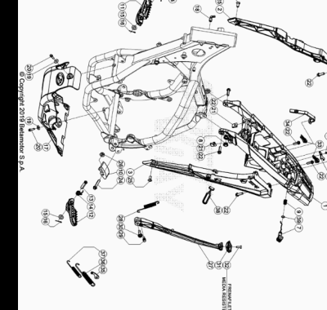

ENDURO_RR_430_4T_RACING_MY22
Ref. | Part Number | Description | Part
1 | 040.32.035.80.59 | CHASIS POSTERIOR | 1
2 | 037.32.033.87.59 | SOPORTE SUBCHASIS | 1
3 | 037.32.034.87.59 | SOPORTE COLA TRASERA | 1
4 | 020.32.010.00.05 | CHAPA FIJ. CERRADURA | 1
5 | 020.32.112.00.00 | EJE CERRADURA | 1
6 | 037.32.013.50.00 | SOPORTE | 1
7 | 037.32.014.87.59 | PULSANTE ASIENTO | 1
8 | 037.38.003.00.00 | SOPORTE | 1
9 | 020.32.016.00.00 | MUELLE | 1
10 | 25.25601.000 | PATIN TENSOR RR 4T 2008 | 1
11 | 037.32.040.00.59 | ESTRIBERA RR RACING | 1
12 | 037.32.039.00.59 | ESTRIBERA RR RACING | 1
13 | 25.54465.000 | EJE ESTRIBERA RR-4T | 2
14 | 037.32.019.00.00 | MUELLE | 2
15 | 031.32.001.00.00 | ARANDELA 10 X 21 X 2 | 2
16 | 12.81993.000 | PASADOR EJE ESTRIBERA | 2
17 | 037.32.018.00.59 | PROTECTOR MOTOR | 1
18 | 27.23470.000 | RACORD MOTOR RK6-50/ TUBO GASOLINA RR-T/ART - RR-4T- RR 125 | 1
19 | 27.42000.000 | ARANDELA PLANA 6.18 | 2
20 | 11.49070.000 | TORNILLO 6X20 RS CH8 | 2
21 | 25.60311.000 | GRAPA TORNILLO M6 ALP 4.0 2008 | 2
22 | 31.64070.000 | TORNILLO ESPECIAL 8X25 CH10 | 6
23 | 31.29810.000 | TORNILLO TBCE 5.12 | 2
24 | 11.55480.000 | TORNILLO 8.40 PF C/ARANDELA | 1
25 | 007.32.032.00.00 | TORNILLO ESP. TSBEI CH6 M8X20 10.9 ZINC | 2
26 | 13.17120.000 | TUERCA M8 BASE CILINDRO | 1
27 | 037.32.010.82.00 | KIT CABALLETE | 1
28 | 037.32.030.00.00 | MUELLE | 1
29 | 11.66615.000 | TORNILLO ESP. CAVALLETE RR 4T 2008 | 1
30 | 11.66614.000 | TORNILLO ESPECIAL CABALLETE RR 4T 2008 | 1
31 | 037.32.017.00.00 | SOPORTE | 1
32 | 31.34400.000 | TORNILLO 6 X 20 | 1
33 | 037.32.027.00.00 | KIT TAPON | 1
34 | 037.43.043.00.00 | GOMA BATERIA | 1
35 | 037.32.031.50.00 | SOPORTE MUELLE CABALLETE | 1
36 | 037.32.029.00.00 | MUELLE | 1
37 | 037.32.028.00.00 | MUELLE | 1
38 | 16.34907.000 | GOMA CABALLETE RR-4T | 1
39 | C02.06.066.00.00 | RETEN 9.52 X 1.78 | 1

ENDURO_RR_430_4T_RACING_MY22
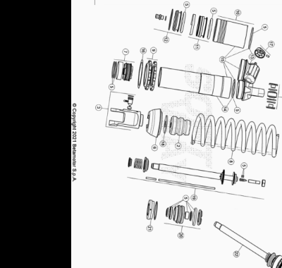

ENDURO_RR_430_4T_RACING_MY22
Ref. | Part Number | Description | Part
1 | 037.33.020.80.00 | AMORTIGUADOR RR 4T | 1
2 | 037.33.009.00.00 | TAPON AMORTIGUADOR | 1
3 | 037.33.010.00.00 | HORQUILLA AMORTIGUADOR | 1
4 | 13.86078.800 | KIT DISTANCIADOR AMORTIGUADOR RRT-4T-GR | 1
5 | 037.33.011.82.00 | KIT JUNTAS | 1
6 | 037.33.012.00.00 | TAPON AMORTIGUADOR | 1
7 | 026.33.020.00.00 | PISTON | 1
8 | 037.33.022.00.00 | MUELLE | 1
9 | 026.33.019.00.00 | TUERCAS AMORTIGUADOR | 1
10 | 026.33.012.00.00 | DEPOSITO AMORTIGUADOR | 1
11 | 026.33.013.00.00 | MEMBRANA | 1
12 | 026.33.014.00.00 | TAPON | 1
13 | 037.33.013.00.00 | TAPON | 1
14 | 037.33.014.00.00 | CUERPO AMORTIGUADOR | 1
15 | 037.33.015.00.00 | CUERPO AMORTIGUADOR | 1
16 | 031.33.012.00.00 | ARANDELA | 1
17 | 026.33.021.00.00 | TAPON REGISTRO | 1
18 | 031.33.014.00.00 | ARANDELA | 1
19 | 037.33.016.00.00 | VARILLA | 1
20 | 037.33.017.00.00 | GUIA | 1
21 | 026.33.026.00.00 | TAPON | 1
22 | 037.33.023.80.00 | VARILLA COMPLETA | 1

